Tyler Young
24 February 2006
Neumont University

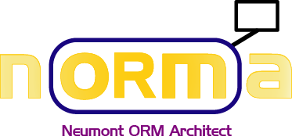

Creating an ORM Model

Creating an ORM Model 2
Introduction 2
Create a new ORM2 file 2
Entity Types 3
Add an Entity Type 3
Add a Reference Mode 3
Set the Data Type 4
Fact Types 4
Add a Fact Type 4
Connect the Roles 4
Add a Reading 4
Fact Editor 5
Internal Constraints 5
Mandatory Roles 6
Add an Internal Uniqueness Constraint 6
Editing the Roles in a Constraint 7
Verbalization Browser 7
External Constraints 8
External Role Set Constraints 8
External Role Sequence Constraints 9
Alethic and Deontic Constraints 10
Objectifying Fact Types 11
Subtyping 12
Navigating the Model 13
Zooming 13
Selecting 13
Copying 13
Model Errors 14
Checking for errors 14
Correcting errors 14
Exploring On Your Own 14
Transforming ORM Models for Fun and Profit 14

Creating an ORM Model

Introduction
Welcome to NORMA!
NORMA stands for “Neumont ORM Architect”. At some point we probably need a fun caricature of an Aussie sheila for a mascot. All you budding graphic designers are welcome to submit ideas! No prizes yet.

In this document, we’ll take a step-by-step approach to creating a very basic diagram, which will hopefully give you the courage to dive in and start using the tool on your own. That way you can find and give us feedback on all the bugs that we haven’t uncovered yet! ☺ For the most part, this tutorial assumes that you have a working knowledge of Object Role Modeling and have used other ORM modeling tools in the past.

At this point, you should have Microsoft® Visual Studio 2005 (VS2005) and NORMA installed on your machine. Start up your Visual Studio and let’s get going!


Create a new ORM2 file
Welcome to NORMA!
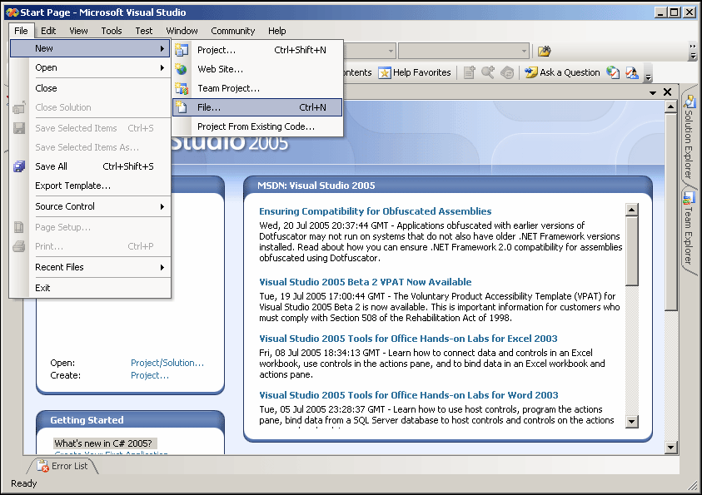
Press Ctrl+N to open a new file.

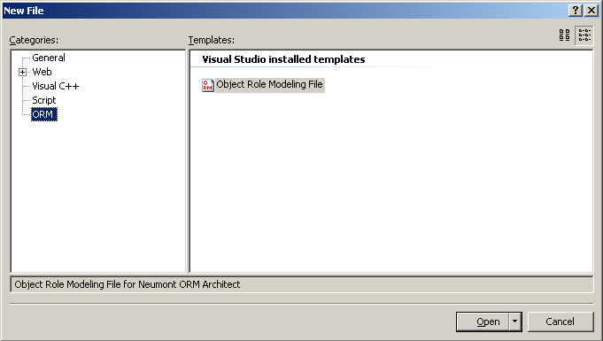
Select Object Role Modeling File.

Entity Types

Add an Entity Type
You’ll now have a blank drawing surface to work with. Press Ctrl+W, then X to bring up the Toolbox. Or you can go to View > Toolbox. During this tutorial, I’ll be including some commonly used keyboard shortcuts that we’ve found useful.
We’ve been trying to put in several ways to access common properties. You’ll find that double-clicking will put you directly into edit mode for some things, right-clicking will let you select ways to interact, and some things you’ll just have to go to the Properties window for.

UI gestures are something that we’ve put a lot of thought into, because the success of any tool depends heavily on how usable it is. Hammers wouldn’t be nearly so popular if you had to do a standing back flip every time you wanted to hit a nail. We’ve tried to make the tool usable, but we realize that what we find to be simple and straight-forward can seem completely obtuse to others. We welcome feedback on the UI gesture set! Let us know what you like and what you don’t, and we’ll hold dozens of meetings about it where donuts will hopefully be in ample supply.
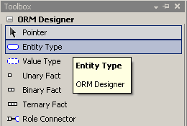

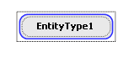
Click once on Entity Type, then click once on the diagram surface to place your first entity type.


Just start typing when you’re ready to enter the name! To rename an entity type you can either select it and start typing (to change the name) or double-click (to edit the name).

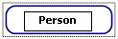
Let’s rename it to something more personable, like Person. Type it in now.

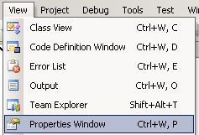
 Add a Reference Mode
We want to add a reference mode for Person, so let’s go to the properties of it. Either navigate from
View > Properties Window, or press Ctrl+W, P

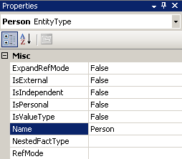
Here you’ll find all sorts of properties that you can change, one of which is Name. We changed that one already, but here’s another place you can change it.

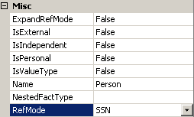
Select the RefMode box, and type in “SSN”.

Set the Data Type
After you press Enter (or click off somewhere else), a new box appears in the properties window for Data Type.
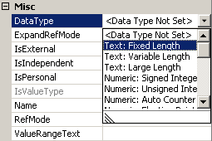
The Data Type is not set for this reference mode. Click the drop-down arrow and select a data type from the menu. I set mine to Text: Fixed Length.

Bring another entity type on to the diagram. Rename it to Car, and give it a reference mode called “VIN” with a data type of your choosing.

Fact Types

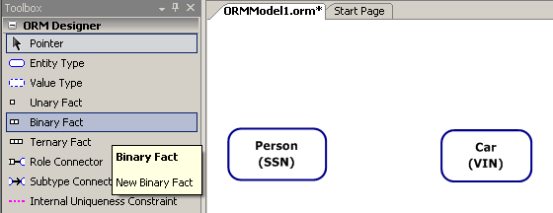
Add a Fact Type
Now we want to bring out a fact type to connect the two entity types. After all, this is fact-based modeling! Click on Binary Fact in the toolbox, then click on some empty space between Person and Car.

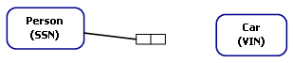
Connect the Roles
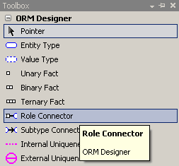
Here’s another UI gesture that you can use to speed things up: After you’ve put your predicate on the design surface, put your mouse in the middle of the left role box. Click and drag from the role box over to Person.

The alternative is to click on Role Connector in the toolbox.

Click on the right-hand role box of our fact type, then click on the Car. The Role Connector is there for people who don’t know the shortcuts. You know the shortcut now. Don’t you feel cool?

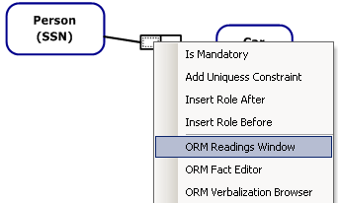
 Add a Reading
Now we need to add a reading to the fact. Right-click on the fact type and select ORM Readings Window.
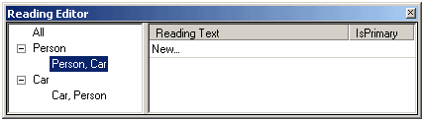
Select the Person, Car reading under Person, then click on New… under the Reading Text column. Don’t type just yet! It takes a moment for the window to give you the interface.
Once you’ve pulled up the readings window, you can dock it and leave it running while you work.

Drag the reading editor window around the screen to experiment with docking it.

When a fact type is selected on the design surface, the window will show you information about its readings. Otherwise, it just gives you the message, “Select an item related to a Fact Type”.

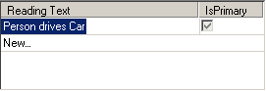
Click to put your cursor between the {0} and the {1} and begin typing. {0} represents the first entity, in this case, Person. {1} is the second, Car. Type in “ drives ” (including spaces before and after “drives”), and press Enter.

This interface is NOT finalized! We’re working hard to improve it, but the changes simply weren’t ready to include in this release.
Notice the IsPrimary column. You can have multiple readings for each combination of entity types in a fact type! Careful though—the tool currently displays ALL the readings at once.

One day when you want to explore things a bit, set up a ternary or quaternary (right-click on a role in a fact type and insert a new role before or after it) and see how many readings you can put in. Wow!
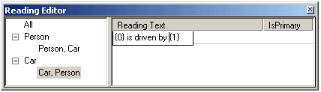
Select Car, Person in the left-hand area, and enter the reverse reading.

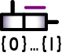 Fact Editor
Other ORM tools, such as Microsoft Visio for Enterprise Architects, allow you to enter fact types by typing them into a window. Not to be outdone, NORMA lets you do that too! The window you need is called the Fact Editor. Right-click somewhere on the drawing surface and choose ORM Fact Editor to bring it up.

Type in fact types just as you would in Visio: Object types have their first letter capitalized, and reference modes are in parentheses (). To see a list of available object types, hit Ctrl + Space to bring up the Intellisense™ list. From there you can arrow up and down and select the one you want by pressing Enter. Type in as many fact types as you want, then hit Ctrl + Enter to commit.

A word of caution about the fact editor… once you commit the fact types, it will try to place the fact type on the drawing surface in an orderly way. It does a very bad job. There are some known bugs that we are working on, and future releases should solve this problem.

Internal Constraints
Internal constraints are constraints that apply only to roles within a single fact type.
The possible internal constraints are

 Mandatory
 Uniqueness
(no picture) Value.

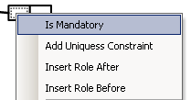
Mandatory Roles
We don’t have any mandatory roles on our model yet, but the internal constraint section is where the mandatory constraint goes. Simply right-click on the role to bring up the context menu and select Is Mandatory. Done.

 Add an Internal Uniqueness Constraint
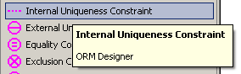
Time to add constraints! Grab an Internal Uniqueness Constraint from the Toolbox by clicking on it.

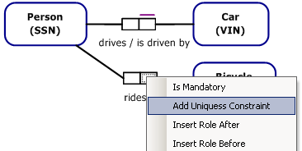
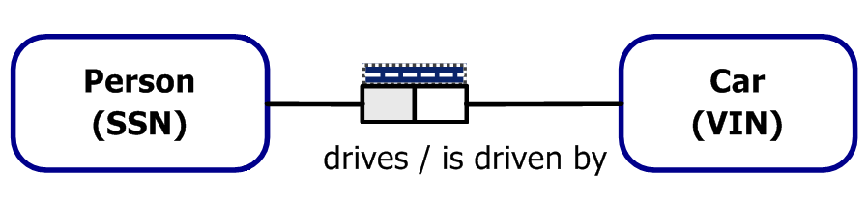
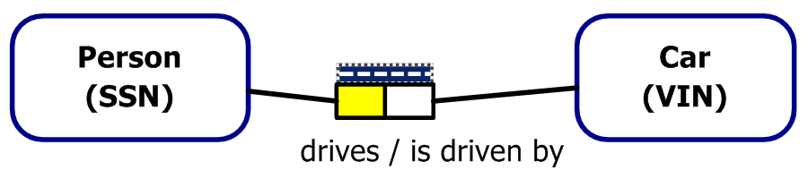
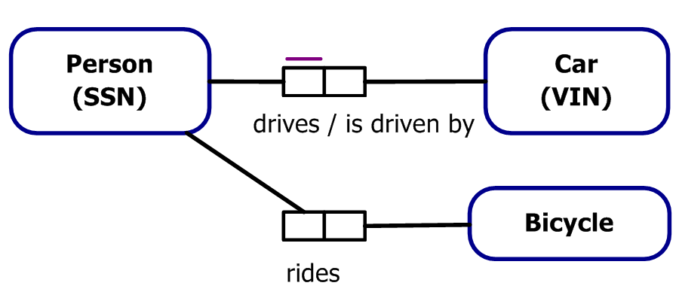
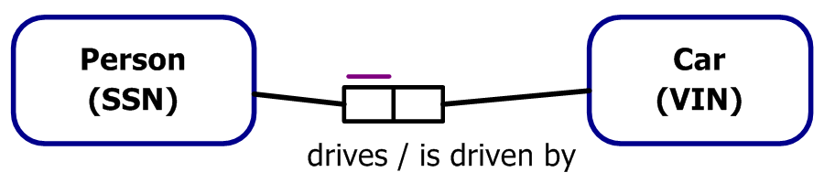
Then click on the Fact Type that you want to add the constraint to. There’s only one Fact Type on the diagram, so choose wisely. ☺

It’s automatically in edit mode, so just click on the role box that Person plays to select it.

Now double-click on the selected role to commit.

This is handy, but as we’ve developed the tool we’ve made an even better way to add internal uniqueness constraints. Add a Bicycle to the drawing, and let’s try it out.

Right-click on the role that you want to add to the Constraint. In this case, it’s the Bicycle’s role in “Person rides Bicycle”. Select Add Uniqueness Constraint and you’re done. Simple!

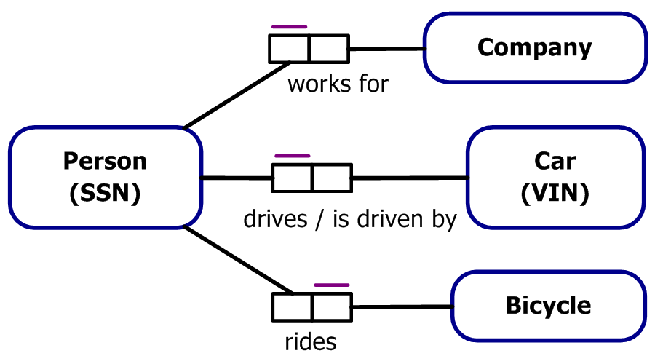

To add a uniqueness constraint to more that one role (fully-spanning, or n-1 for n-ary fact types), just hold in Shift as you click the roles to select them, then right-click and select Add Uniqueness Constraint.

Now practice your new skills by entering the rest of this model.

At this point it’s worth mentioning again that the right-click Context Menu is your friend. We’ve worked hard to get the most commonly used modeling features into that menu without cluttering it too badly. Role should be mandatory? Right-click it. Want another role in the Fact Type after this one? Right-click and you’ll get the option. We realize that Apple fans may complain, but maybe they’ll have suggested a better UI paradigm by the time we port it to OS X.

Editing the Roles in a Constraint
But wait, we made a mistake! Upon further validation with the domain expert, we discovered that a Person can work more than one Company. Let’s fix our model to reflect that.
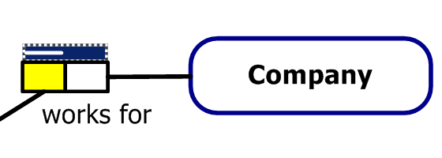
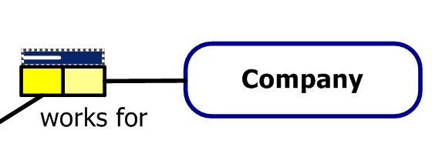
Double-click on the internal uniqueness constraint. That puts us in edit mode.
If you want to remove a role, hold in the Ctrl key while you click it.

Keep in mind when you’re adding and removing roles that when you commit the constraint you need to double-click on a role that’s in the constraint. They’re easy to see because they’re yellow!

Click on the role that Company plays to add it to the selected roles

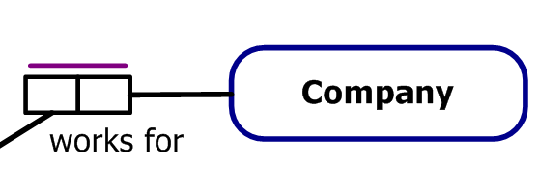
Finally, double-click on any of the yellow, selected roles to commit this role set.

Now we’ve fixed the incorrect constraint. Whew!

Verbalization Browser
One of the powerful features of ORM is that you can verbalize anything on the diagram in plain, natural language. While NORMA is currently implemented with English language and grammar, you can swap out the verbalization file easily enough to localize the readings. Swapping out the language file is beyond the scope of this tutorial on how to make a model. So why did we bring it up? Because it’s cool and you care.
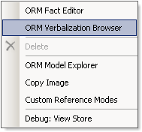
To access the verbalizer, right-click on any blank space on the diagram. The drop-down context menu appears, and from there you can click on ORM Verbalization Browser. Visual Studio lets you dock these tool windows in various places, so it may be floating on the diagram or it may be docked somewhere on the edge of the diagram. Either way, it will look something like this:

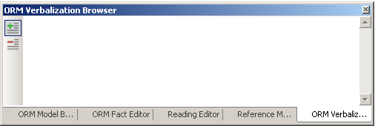
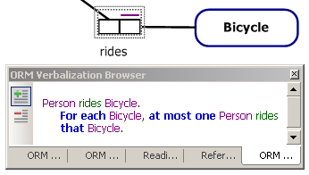
Any fact type or constraint on the drawing surface is fair game in the Verbalizer. Click on our Person rides Bicycle fact type to begin with.

And just like that, you have a natural-language business rule that you can go validate with your domain expert. Object types are violet, readings are green, and the verbalizer puts key words and phrases in blue.

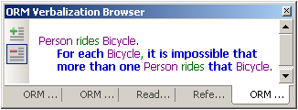
But wait, there’s more! See that green plus (+) and red minus (-) on the left-hand side? Those are for selecting between positive and negative verbalizations. Positive verbalizations are the default. Click on the minus (-) now.

And voila, the fact type is rephrased in a way that shows how the constraint can be violated. Now, back to the verbalization file that is out of the scope of this document… It’s possible to specify readings in any language, and it’s even possible to specify multiple readings so that you can rephrase a fact type when the domain expert starts scratching his/her head. All you have to do is enter the verbalization data into the XML file according to the schema. We’re mentioning this so much because we need some enterprising individuals who can do the verbalizations in their native languages. If you’re one of those individuals, please contact us if you need help, and let us know when you’re done so that we can share your work with the community by including that language support in future releases.

External Constraints
Now that we have a more fully populated (and more correct) model, let’s add some external constraints.

External Role Set Constraints
The possible External Role Set constraints are:

Disjunctive Mandatory
External Uniqueness
Frequency
Ring (irreflexive shown)

External role set constraints operate on a set of type-compatible roles. Obviously! What it means is that all the roles in the constraint’s role set must be played by either the same object type or sub/supertypes of it. For example, if one of the roles in the constraint is Person, then all the roles in the constraint must be played by a Person or by a sub/supertype of Person.

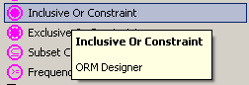
Working from the example we were talking about, let’s force everyone in our domain to either drive a Car or ride a Bicycle. No carpoolers or walkers on the way to work in our Universe of Discourse—the employer has a strict policy against that. Maybe after you show off the model you can get it changed.

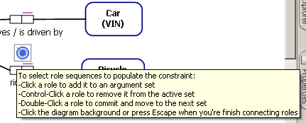
Start by grabbing an Inclusive Or Constraint from the Toolbox.

Place it on the diagram between Person drives Car and Person rides Bicycle. In this universe you can’t walk to work, and there’s no car pooling allowed!
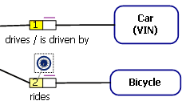
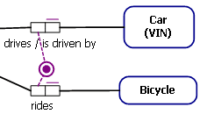
Click on the roles that Person plays in each of these fact types.

Double-click either of these roles to commit the new constraint, and we’re done. Now show the model to the boss and see if you can’t get a ride share program started!
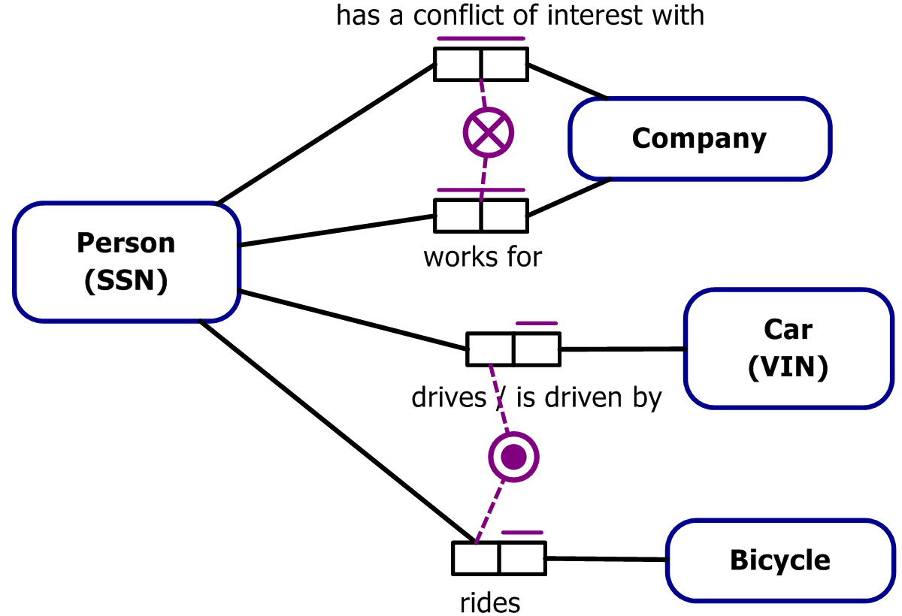

External Role Sequence Constraints
Let’s extend our model a bit so we have something interesting to put a set constraint on. Make it so it is possible that one Person has a conflict of interest with the same Company and that the same Person has a conflict of interest with more than one Company.

Next, you need to know what the difference is between a role set constraint and a role sequence constraint. Recall that role set constraints operate on a set of roles that are all type-compatible. Role-sequence constraints operate on sequences of roles that are type-compatible. Each role inside a sequence may map to a different object type, but the same role position between sequences will be type-compatible. If you viewed the sequences as rows in a table you would see that the each role in any given sequence is type-compatible with the “column”. To help you visualize it, here’s a populated table:
The possible External Role Sequence constraints are:

Equality
Exclusion
Subset

 | Role 1 | Role 2
Role Sequence 1 | Person | Company
Role Sequence 2 | Person | Company

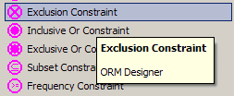
Now we’re ready to start. Grab an Exclusion Constraint from the toolbar, and click somewhere between the Person has a conflict of interest with Company and Person works for Company fact types to set the constraint down.

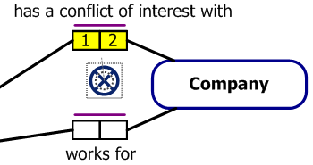
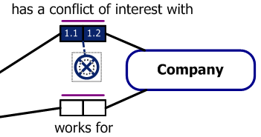
As usual, once you put the constraint down you’re automatically in edit mode. Click on Person’s role for the “has a conflict of interest with” fact, then on Company’s role and double-click on either of those roles to commit the role sequence.

Take a moment to notice now that you’re STILL in edit mode!! Again, set constraints accept more than one set of roles.
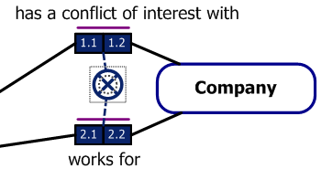
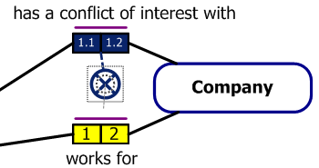
Click on Person’s role in “works for”, then on Company’s role, and double-click on any of those selected roles to commit the role sequence. And yes, you’re still in edit mode because you can add many role sequences. Either click to an empty place on the diagram or press Esc to finish the constraint.

If you need to add another role sequence to a set constraint that’s already been committed, double-click on the constraint. To edit one of the existing role sequences, click on the constraint to select it (so that the role sequences are shown in blue, as they are in the picture here), then double-click on any role in the role sequence that you want to edit.

In some of the more advanced models out there, there are actually (rare) reasons to have overlapping role sequences where a role appears in more than one role sequence. If you’re a beginner and you need to do this, find an experienced Object Role Modeler to talk you out of it. If you know what you’re doing and you insist on doing it anyways, the tool will show {…} instead of 2.1, 2.2, etc. NORMA will let you create the model, but editing the role sequences that are overlapping can be problematic.

Alethic and Deontic Constraints
Throughout this tour of NORMA we’ve assumed that you have worked with ORM before and have maybe even used some of the existing tools. By popular demand (popular being a relative term), we’ve included deontic constraints in the ORM2 specification. Since this has never been implemented in any tool before NORMA, it bears a bit of explaining.

Up to this point, all constraints have been alethic. In other words, it is impossible to break the constraint. In a system that implements an alethic constraint, when a user tries to do something illegal the system will politely tell the user, “Hah, nice try buddy! Take a hike.”

Deontic constraints, on the other hand, are constraints that are forbidden to be broken. If a user tries to break a deontic constraint, the system might reply, “Well… okay. But I’ll have you know that this is strictly forbidden and I’m going to have to tell my supervisor about this.”

A brief example may help. Alethic: You’re hiking near the Grand Canyon. You step off the edge of the cliff in an attempt to break the constraint of gravity. Gravity is an alethic constraint. You fall to a quick and messy death.

Next example, Deontic: You are at a football match. You feel the need to express your exhibitionist tendencies and you run from the restroom onto the playing field wearing nothing more than what Mother Nature gave you. As you are being tackled by security guards, you realize that although no laws of nature stopped you from breaking the constraint, “No person shall run naked on the field while play is in progress,” there are consequences to your actions that will have to be dealt with.

In simple terms, alethic constraints cannot be broken and deontic constraints should not, but may be broken.

By default, all constraints in NORMA are alethic. To make a constraint deontic, select it by clicking on it, then go to its properties. Either click on the drop-down box next to Modality, or simply double-click on Modality to toggle back and forth between alethic and deontic.
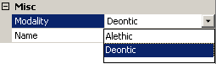
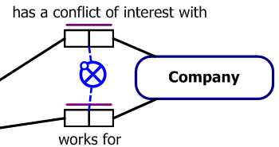
When you change a constraint to deontic, the color will change from violet to a light blue. There will also be a change to the icon used to represent the constraint. Since it’s forbidden but possible for a person to have a conflict of interest with a company that they work for, let’s make our exclusion constraint deontic.

To help you recognize the differences, here are some pictures of different constraints in their alethic and deontic forms.


Objectifying Fact Types
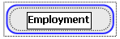
At this point we want to specify more information about the relationship, Person works at Company. For convenience in modeling, let’s call it “Employment”. To do this, create a new object type and call it Employment.

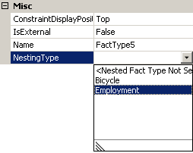
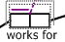
Now select the fact type that has the reading, works for and go to the properties (Remember, F4 is the shortcut if you haven’t pinned the Properties window down), to find the Nesting Type property. Drop the list down and choose Employment.

But what’s this? You see that we have two choices, Bicycle and Employment. Why is that? NORMA will let you choose any object types that do not have a reference mode already defined. So why doesn’t Company show up in the list? NORMA won’t let you choose an object type that plays a role in the fact type that you’re trying to objectify. Think about it… if you were to objectify this fact type as Company, you’d have something like, “Person works for Company, and that fact type is objectified as Company”. If that sounds confusing and illogical, you’re right. Which is why you don’t get that option.

After you’ve selected Employment as the Nesting Type, rearrange things a bit on your diagram so that it looks pretty. If anybody reading this document has a great algorithm for an automatic layout engine that they’d like to share, please let us know!

Subtyping
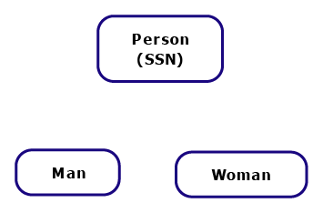
First, add Male and Female entity types.

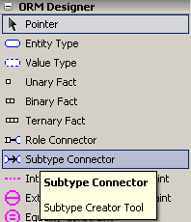
Go to the toolbox and select the Subtype Connector.

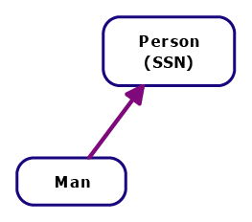
Click on the object that you’re going to subtype first, then on its supertype. In this example, click Man, then Person. Do the same for Woman, and you have the fact that a Person can be a Man or a Woman. Or both. Hmmm, that’s a problem! Since we’re going to take the traditional interpretation of man and woman (that each person must be either a man or a woman, but not both!), we need to put an exclusion constraint on these subtypes.

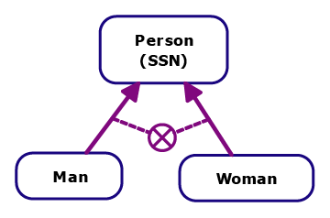
Click on Exclusion Constraint in the toolbox, then between Man and Woman to put the constraint on the diagram. It’s ready to accept role sequences now. Remember that an exclusion constraint is a set constraint, so you need to double-click on the subtype arrow that connects Man to Person, then double-click on the subtype arrow connecting Woman to Person. Now, a Person can be either a Man, or a Woman, but not both.

There’s one more thing we need to add. Since people must have a specified gender and since child labor laws are strictly enforced in our model, each Person must be a Man or a Woman. Go ahead and add the mandatory constraint to the subtypes. Just remember that mandatory constraints are single-role constraints as opposed to the set constraint that we just added. How does adding a single-role constraint differ from adding a set constraint?

Navigating the Model

Zooming
Somewhere along the line you’re going to want to zoom in to your model and have a closer look at what’s going on. Hold in Ctrl + Shift, and it will change your cursor to be a magnifying glass. Left-click anywhere on the model and it will zoom in. Right-click will zoom out.

Selecting
For moving things around on the drawing surface, sometimes it’s useful to select more than one thing at a time.

The fastest way to select multiple objects is to click and drag a selection box around all the objects you want to get.

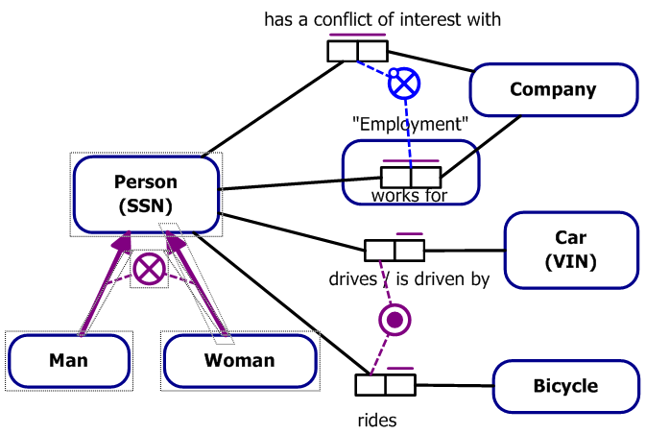
Sometimes, though, you just can’t get all the objects you want in a box. Hold in Shift while you click on the objects that you want to add to your selection.
To remove something from the group of selected items, hold in Ctrl while you click it.

Copying
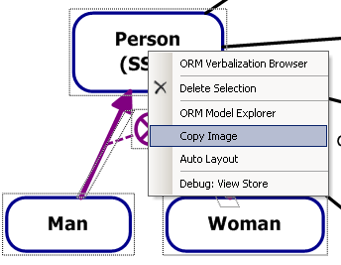
The standard copy shortcut, Ctrl-C, won’t work for objects and shapes in NORMA. What you need to do is make your selection, then right-click. Select Copy Image from the context menu that appears.

If you don’t have anything selected when you right-click, NORMA will either copy the entire diagram (if you right-clicked on an empty area), or the single shape that you right-clicked on.

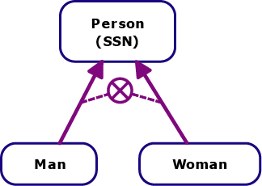
If you do have several objects selected and you right-click on one of the selected objects, NORMA will copy all of those objects. From the example above, the copied image looks like this:

Model Errors
Conceptual modeling is hard work. If you’re going to use your model for anything other than wallpaper, it has to be complete and correct. NORMA will help you out with the Error List.

The error list is pretty much exactly what it sounds like it is. Whenever you do something that is a conceptual error it will immediately show up in the list. Try pinning the error list open while you’re make a model. NORMA will keep you updated on things that you need to do in order to make the model conceptually correct.

Checking for errors
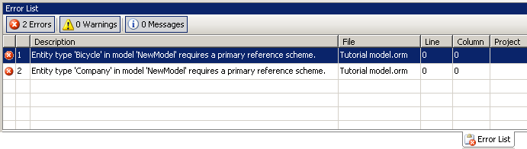
To access the error list, you can either go to View > Error List or press Ctrl+\, Ctrl+E. Open the error list now, and see what conceptual mistakes we’ve made so far.

You can see easily that we need to create primary reference schemes for Bicycle and Company.

Correcting errors
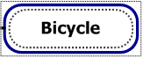
Now that we know what we need to fix, double-click on the first error. The object that the error is attached to gets selected on the diagram. In this case, it’s Bicycle.

Correct these two model errors by adding reference modes.

Exploring On Your Own
So there you have it! You’ve created a new ORM2 diagram, populated it with object types and with fact types, added readings, and you’ve even put some basic external constraints on your diagram. There’s still more for you to explore, though. Keep the properties window handy and click on various things on the diagram to see what it lets you change. You’ll be able to turn entity types into value types, add names to roles, and much more!

Transforming ORM Models for Fun and Profit
Once you have a model, there are many things you can do with it. For one, you can wallpaper your living room in a conversation-inspiring way. A more popular use for ORM models is creating databases. The scope of this document is limited to creating a model, so we won’t go into databases here except to say that it can be done, and a future tutorial will walk you through doing it. Other tutorials may include creating an XSD file, and generating an object-oriented class model.

Questions about this tutorial can be posted in the ORM2 discussion group hosted by Sourceforge.net or directed to the author, Tyler Young (tyler.young@student.northface.edu).

